**Azure Load Balancer**

1. its use for balance the traffic.
2. Azure load balancer work for os layer 4.
3. Azure load balancer use for distribute traffic.it is distribute the incoming traffic.

### ****Azure Load Balancer components****

**Fronted IP:**

In Azure load balancer the term “fronted ip” refer to the public ip address that clients use to connect to the load balancer.

**Backend Pool:**

It is collection of virtual machines.

**Inbound rules:**

Inbound rules control incoming traffic to a network or system.

**Outbound rules:**

Outbound rules control outgoing traffic from a network or system.

**Health Probes:**

A health probe is for determining the health status of the instances in the backend pool.

**Public Load Balancer:**

[**public load balancer**](https://learn.microsoft.com/en-us/azure/load-balancer/components#frontend-ip-configurations) can provide outbound connections for virtual machines (VMs) inside your virtual network. Public Load Balancers are used to load balance internet traffic to your VMs.

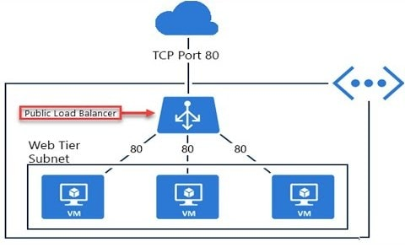

**Internal Load Balancer:**

An internal load balancer direct traffic only to resources that one inside a virtual network or that use a vpn to access to azure infrastructure.

**Step 1:**

**First Create two virtual Machine in Azure portal**

**Step 2:**

**Create load balancer**

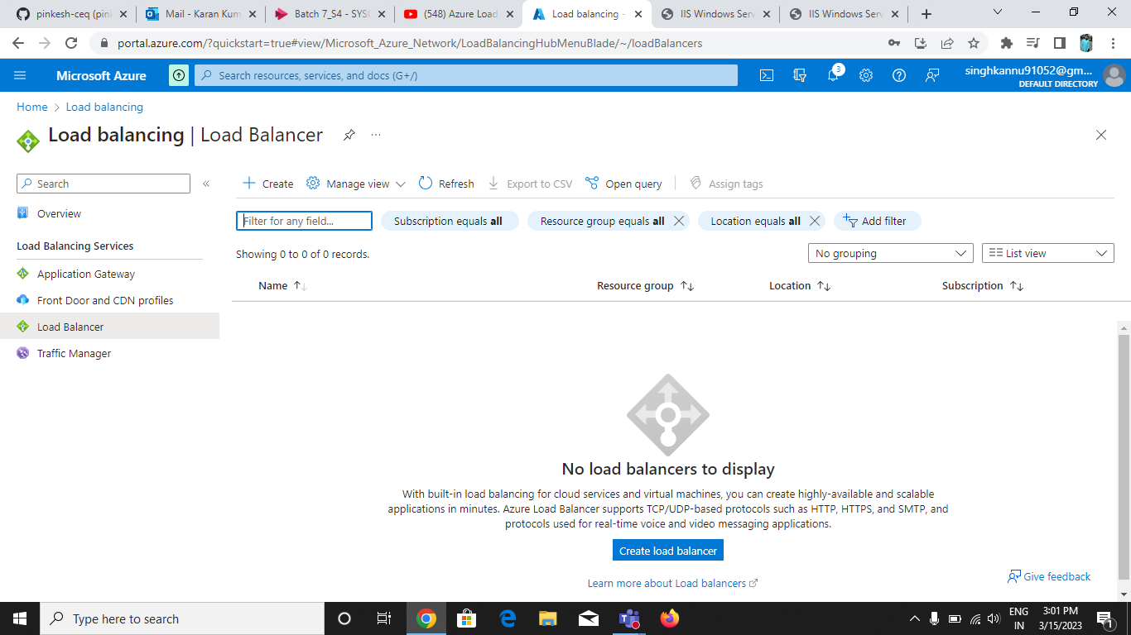

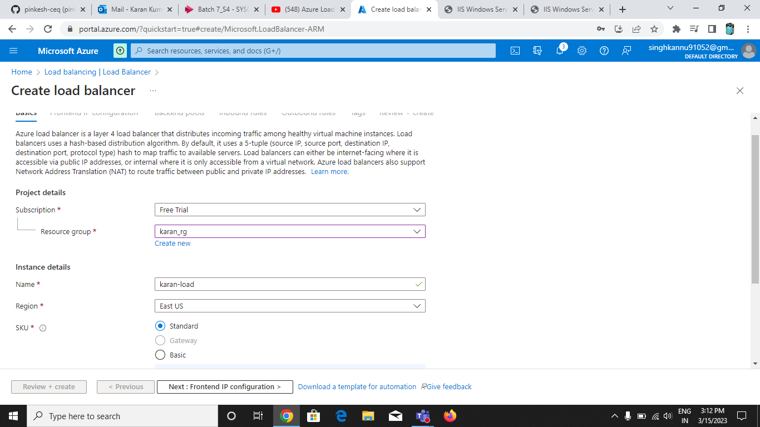

**Add Fronted IP Configuration:**

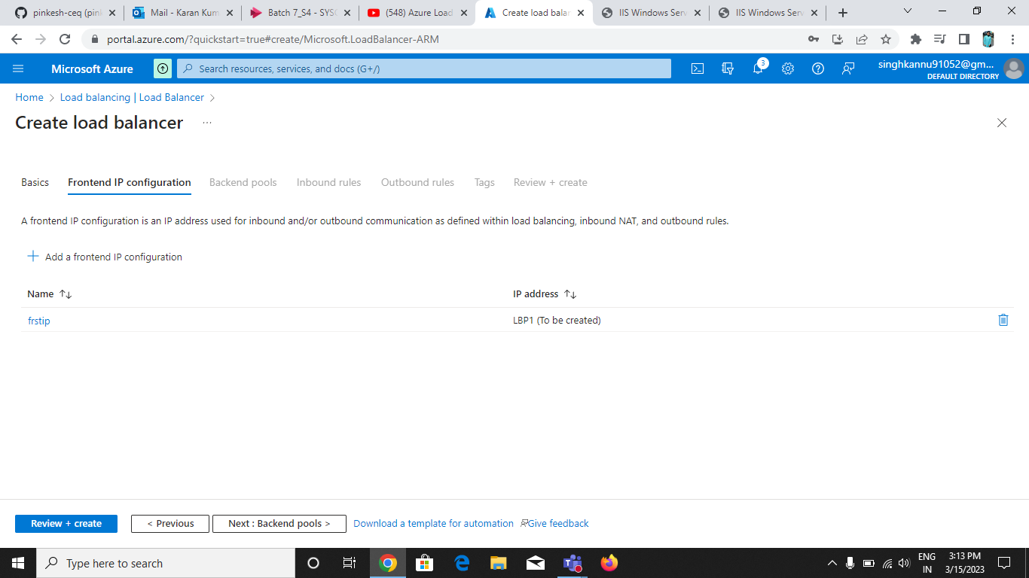

**Add on Backend pools:**

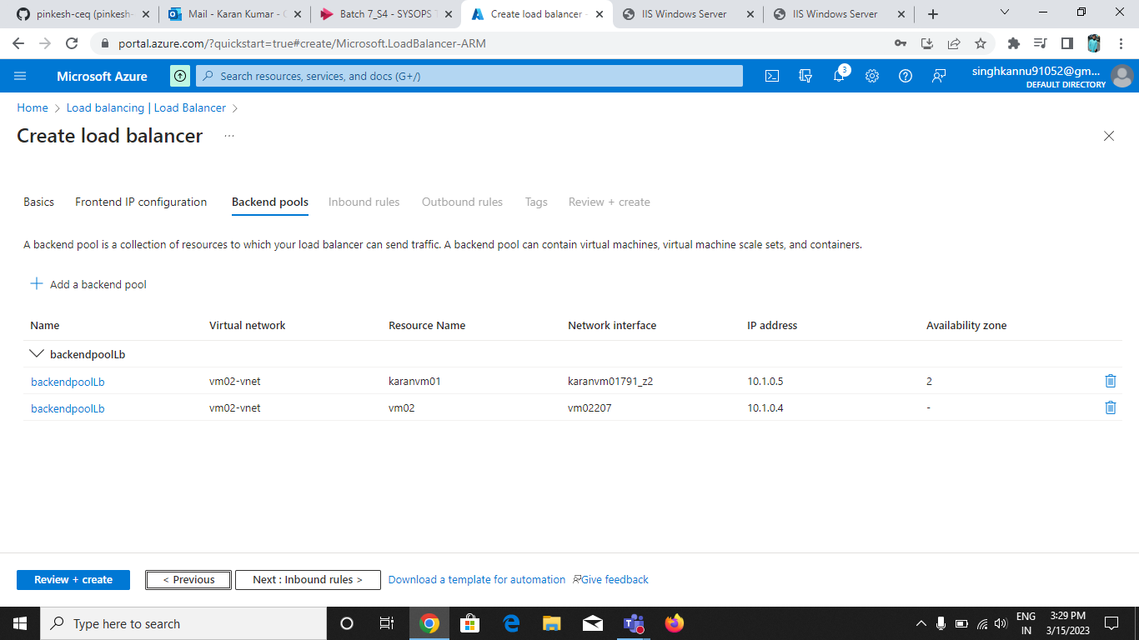

**Include Inbound Rules:**

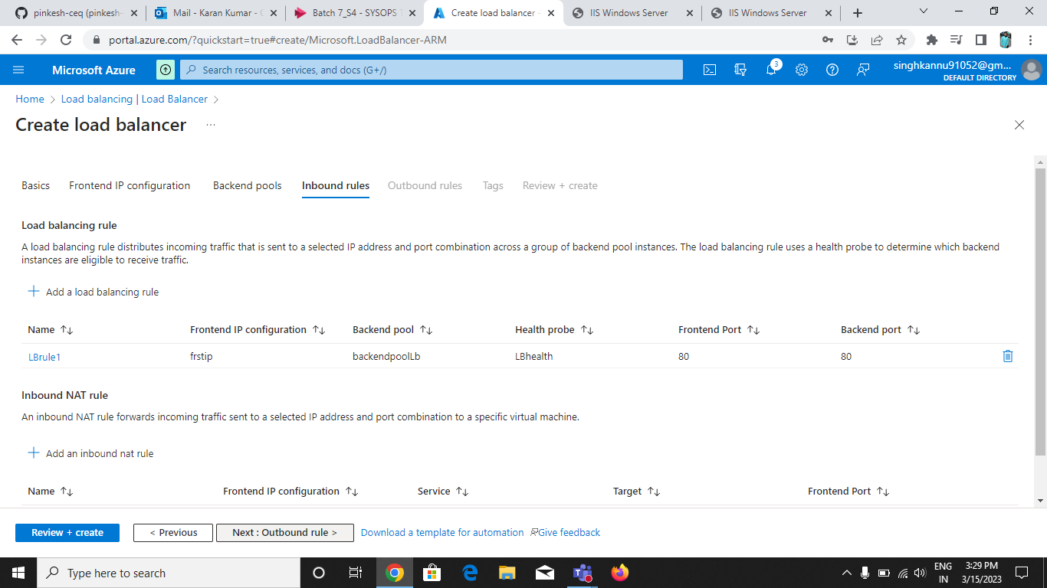

**Validation Done:**

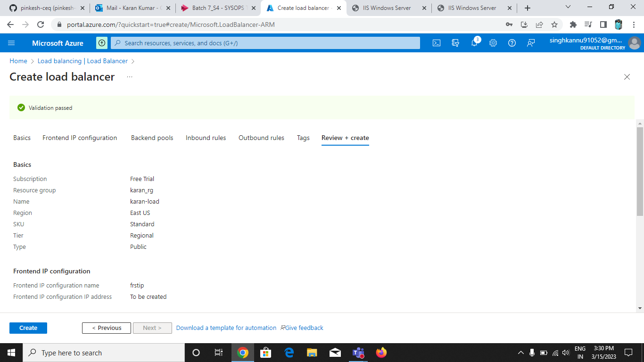

**Create load Balancer is done and deployment also done for load balancer:**

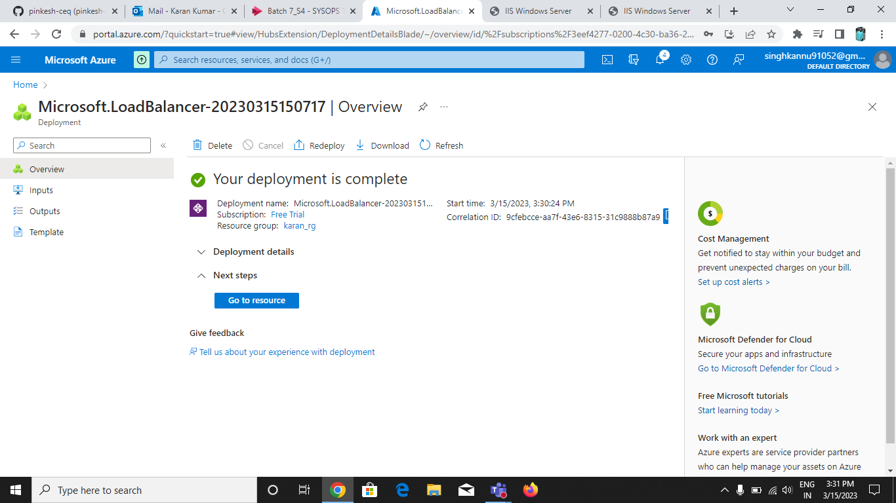

**Fronted IP Configuration Done:**

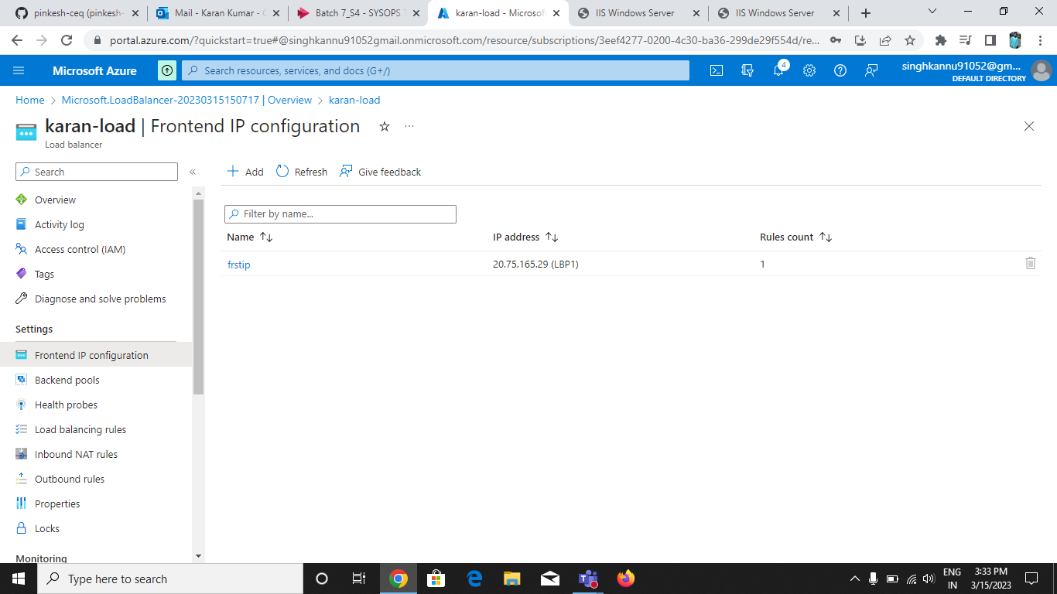

**Backend Pools Done:**

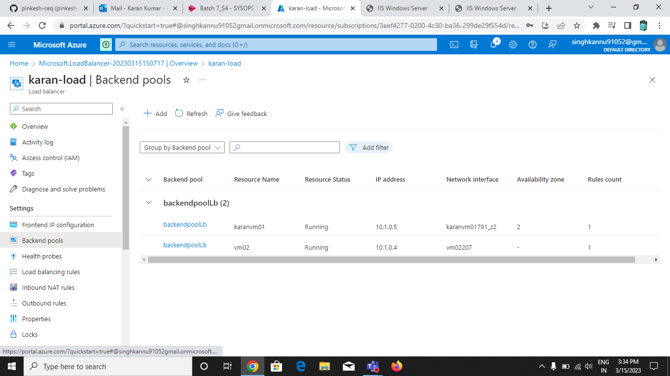

**Health Probes done:**

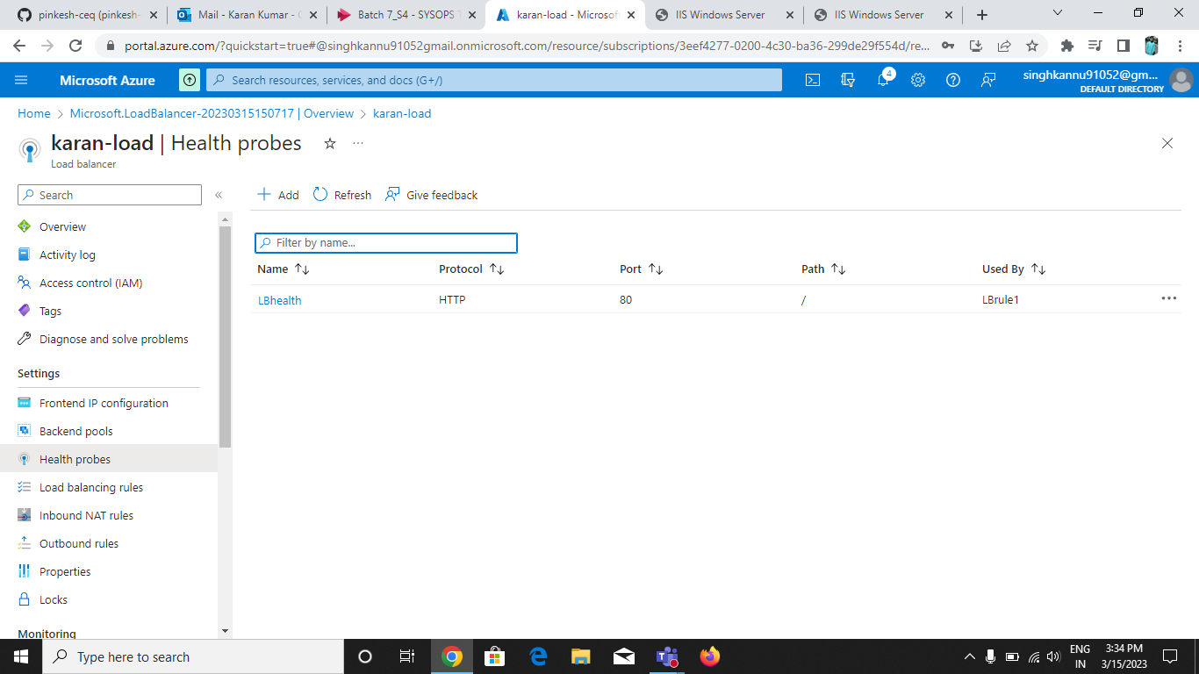

**Load Balancer:**

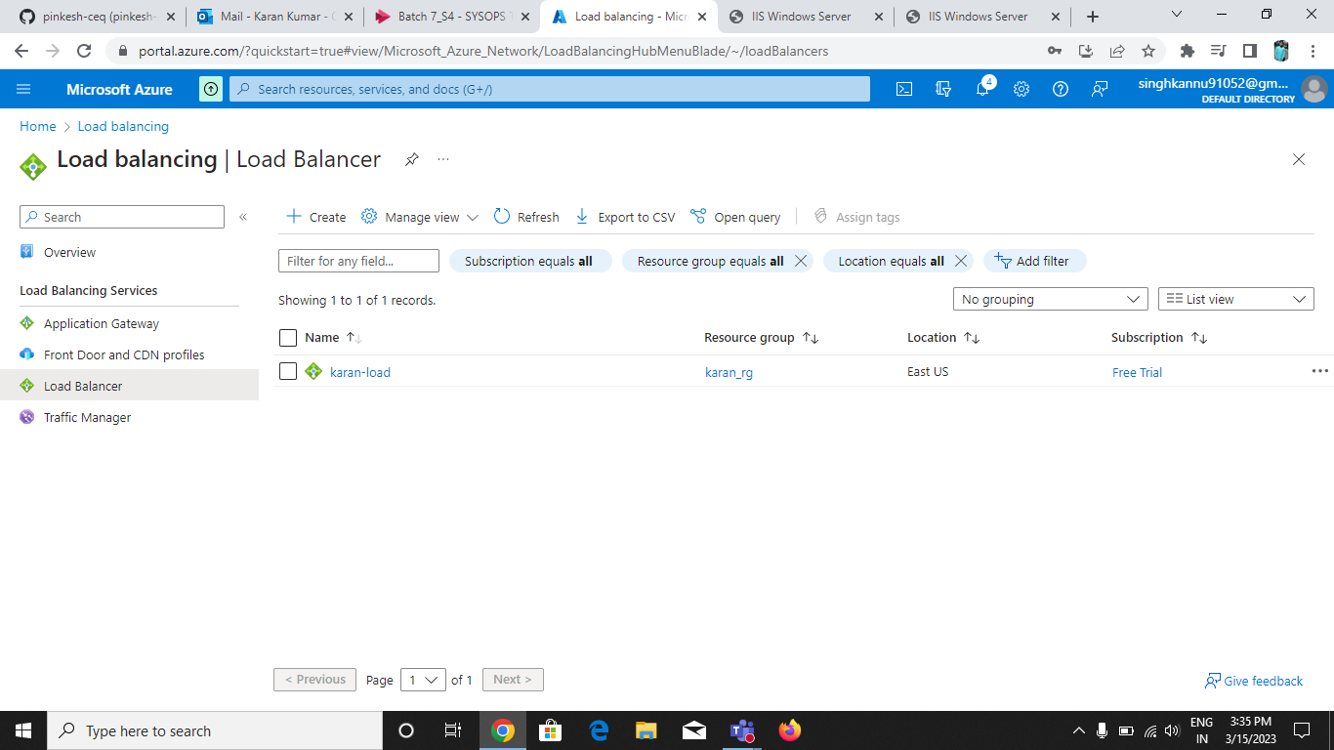

**The Result is :**

**First server is:-**

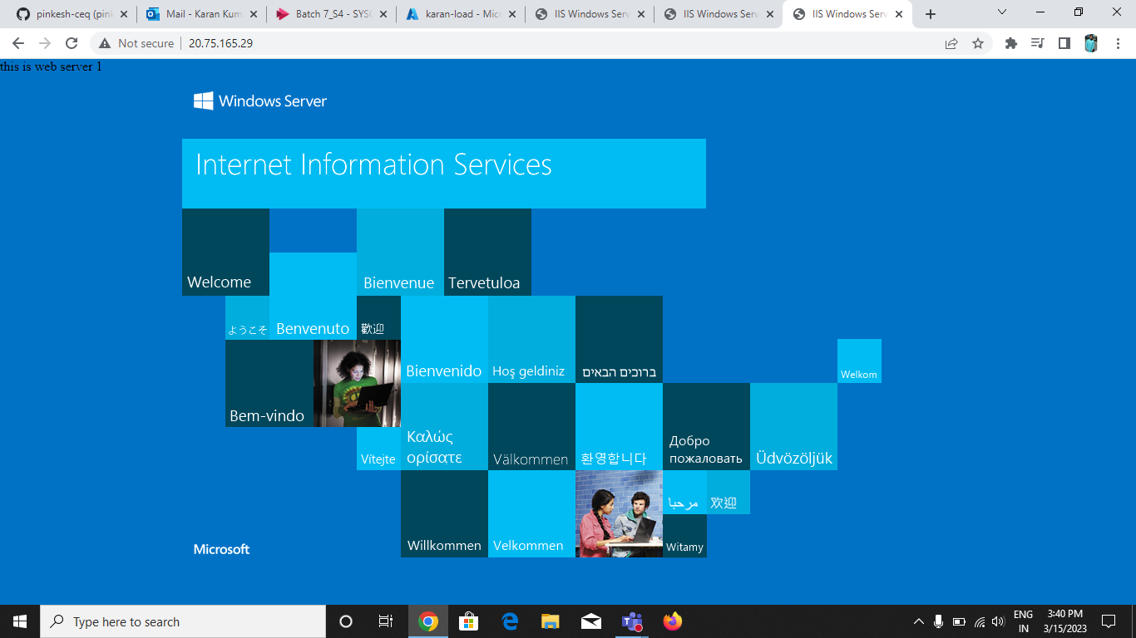

**Second Server is:**

